How to do Caching, Throttling, and Canary deployment in API Gateway?

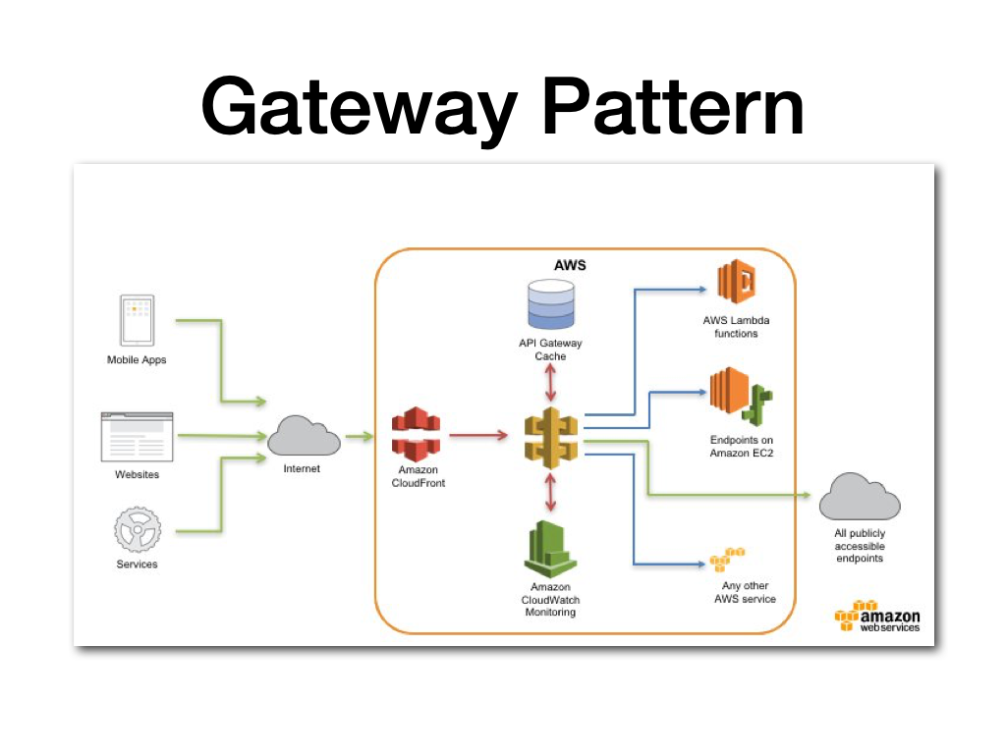

API Gateway is a managed service offered by AWS that allows you to create, deploy, and manage APIs at scale. Here's how you can implement caching, throttling, and canary deployment in API Gateway:

Caching:

API Gateway provides built-in caching functionality that can be enabled for your APIs. You can configure caching at the stage level, and set a time-to-live (TTL) value to control how long the cached responses are stored. To enable caching for your API, follow these steps:

Open the API Gateway console and select your API.

Select the stage for which you want to enable caching.

Under the Settings tab, select the Enable API caching checkbox.

Set the TTL value for the cached responses.

Save the changes.

Throttling:

Throttling is used to limit the number of requests that can be made to an API within a given time period. API Gateway provides several ways to implement throttling, including by IP address, API key, and usage plan. To enable throttling for your API, follow these steps:

Open the API Gateway console and select your API.

Select the stage for which you want to enable throttling.

Under the Settings tab, select the Enable throttling checkbox.

Select the type of throttling you want to implement.

Set the maximum number of requests and the time period for which the limit applies.

Save the changes.

Canary Deployment:

Canary deployment is a technique used to gradually roll out changes to an API, allowing you to test the changes in a small subset of the traffic before making them available to all users. API Gateway provides a canary deployment feature that allows you to deploy a new version of your API alongside the existing version, and gradually shift traffic from the old version to the new version. To enable canary deployment for your API, follow these steps:

Open the API Gateway console and select your API.

Select the stage for which you want to enable canary deployment.

Under the Settings tab, select the Enable canary deployment checkbox.

Set the percentage of traffic to be routed to the canary deployment.

Set the deployment stage for the canary deployment.

Save the changes.